STUDENT |  | GRADER | Total Score
 |  |  | Total Score
  I am submitting my own work, and I understand penalties will
  be assessed if I submit work for credit that is not my own.
   | Print Name |  | ID Number
   | Sign Name |  | Date
  # | Points | Score
  1 | 4
  2 | 3
  3 | 4
  4 | 6
  5 | 8
  6 | 9
  7 | 5
 |  |  | Weeks late
 |  |  | Adjusted Score
 |  |  | Adjusted Score
  Estimated Work Hours
  1 | 2 | 3 | 4 | 5 | 6 | 7 | 8 | 9 | 10
  1 | 2 | 3 | 4 | 5 | 6 | 7 | 8 | 9 | 10
  Overall Weight
Adjusted Score:
Deduct 20% from score for each week late

Problem 1. Write the following equations in logic assignment (VHDL) form.

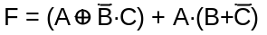

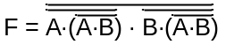

Problem 2. Write VHDL statements to define circuits with the behavior defined by the truth tables below.

A | B | C | F
0 | 0 | 0 | 1
0 | 0 | 1 | 1
0 | 1 | 0 | 0
0 | 1 | 1 | 0
1 | 0 | 0 | 0
1 | 0 | 1 | 0
1 | 1 | 0 | 1
1 | 1 | 1 | 1

A | B | C | F
0 | 0 | 0 | 0
0 | 0 | 1 | 0
0 | 1 | 0 | 1
0 | 1 | 1 | 0
1 | 0 | 0 | 0
1 | 0 | 1 | 1
1 | 1 | 0 | 0
1 | 1 | 1 | 0

A | B | C | F
0 | 0 | 0 | 1
0 | 0 | 1 | 1
0 | 1 | 0 | 0
0 | 1 | 1 | 0
1 | 0 | 0 | 1
1 | 0 | 1 | 1
1 | 1 | 0 | 1
1 | 1 | 1 | 1

Problem 3. Write VHDL statements to define circuits with the behavior defined by the equations below.

F=Σm(0,2,7,9,10,11,14) + φ(4,5)

Y = Π M (0,2,4,8,9,10,14,22,31) + φ(6,7,12,13,24,25)

Problem 4. F is a three-bit std_logic bus. Write VHDL to define the bits of F according to the equations: F(1) = Σ m (0, 3, 4), F(2) = Σ m (1, 6, 7), F(3) = Σ m (0, 1, 3, 4)
Problem 5. Write VHDL statements to define circuits with the behavior defined by the schematics below.

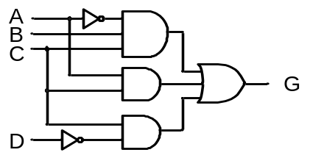

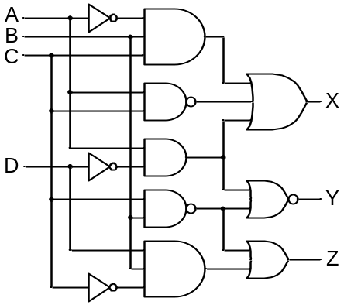

Problem 6. Six judges are scoring a particular event, and they need a device to help them decide how well the event is received. Each judge has a single switch that they can use to enter a “like” or “dislike” vote (assume a switch outputs a '1' for "like"). Use VHDL to define a circuit that can indicate three separate conditions: A "strong majority like" of either 5 or 6 “good” votes; a "majority like" of 4 or “good” votes, and a "minority like" of exactly 3 “good” votes.

Problem 7. A thermometer produces a continuously varying voltage signal between 0V and 5V, where 0V represents 0 degrees, and 5V represents 100 degrees. The signal is fed to an analog-to-digital converter (ADC). The ADC produces an 8-bit binary number that is directly proportional to the temperature – “00000000” represents 0 degrees, each increasing binary number from “00000000” represents a temperature increase of 100/256 degrees, and “11111111” represents 100 degrees. Use VHDL to define a circuit that outputs a logic high signal whenever the temperature is between 50 and 60 degrees.

